In order to protect our Board documents and make Officer transitions easier, please save any documents created for GEPC as follows:
- Go to the GEPC home page, log in and select ADMIN from the left hand side of the home page. (Note: ADMIN appears when you, as a Board Member log in.)


- Scroll down the left side to find and select Document Library.
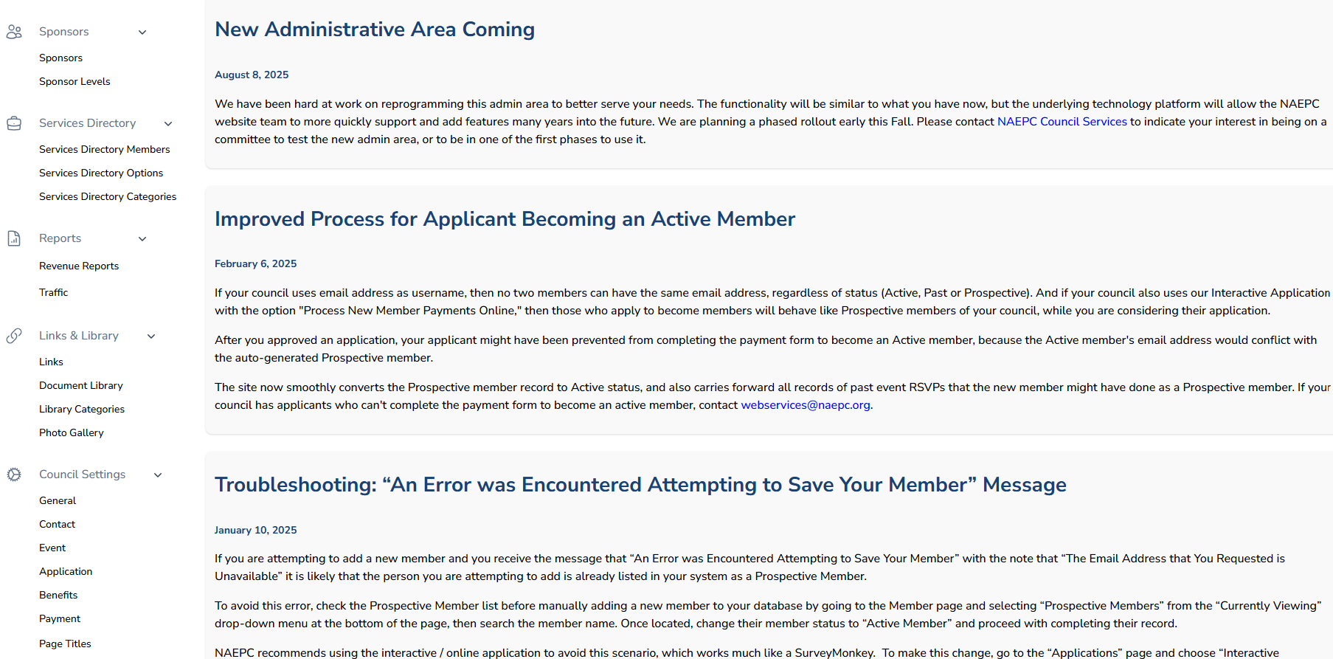

- Select Add Document to upload your document. Please try to upload a version that can be most easily updated the following year (i.e. MS Word would be better than pdf) for the person rolling it forward. Any douments that are rolled forward annually should include the organizational year for which they are updated (i.e. 2026 2027) at the beginning of the filename while any standing documents should not include the organizational year.
