In order to create and send meeting announcements for monthly meetings:
- Go to the GEPC home page, log in and select ADMIN from the left hand side of the home page. (Note: ADMIN appears when you, as a Board Member log in.)
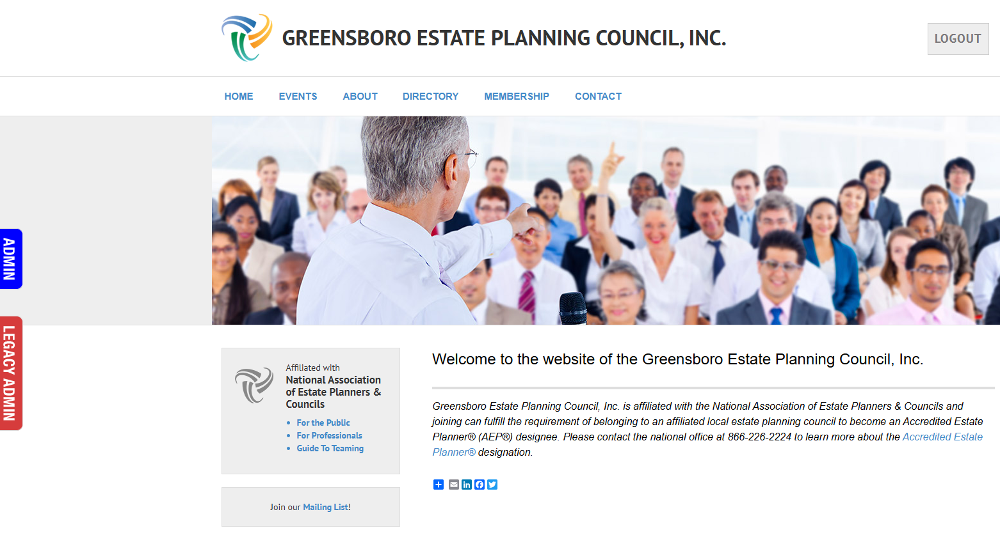

- Scroll down the left side to find and select Message History. Then, select View Message beside one of the recent Messages.
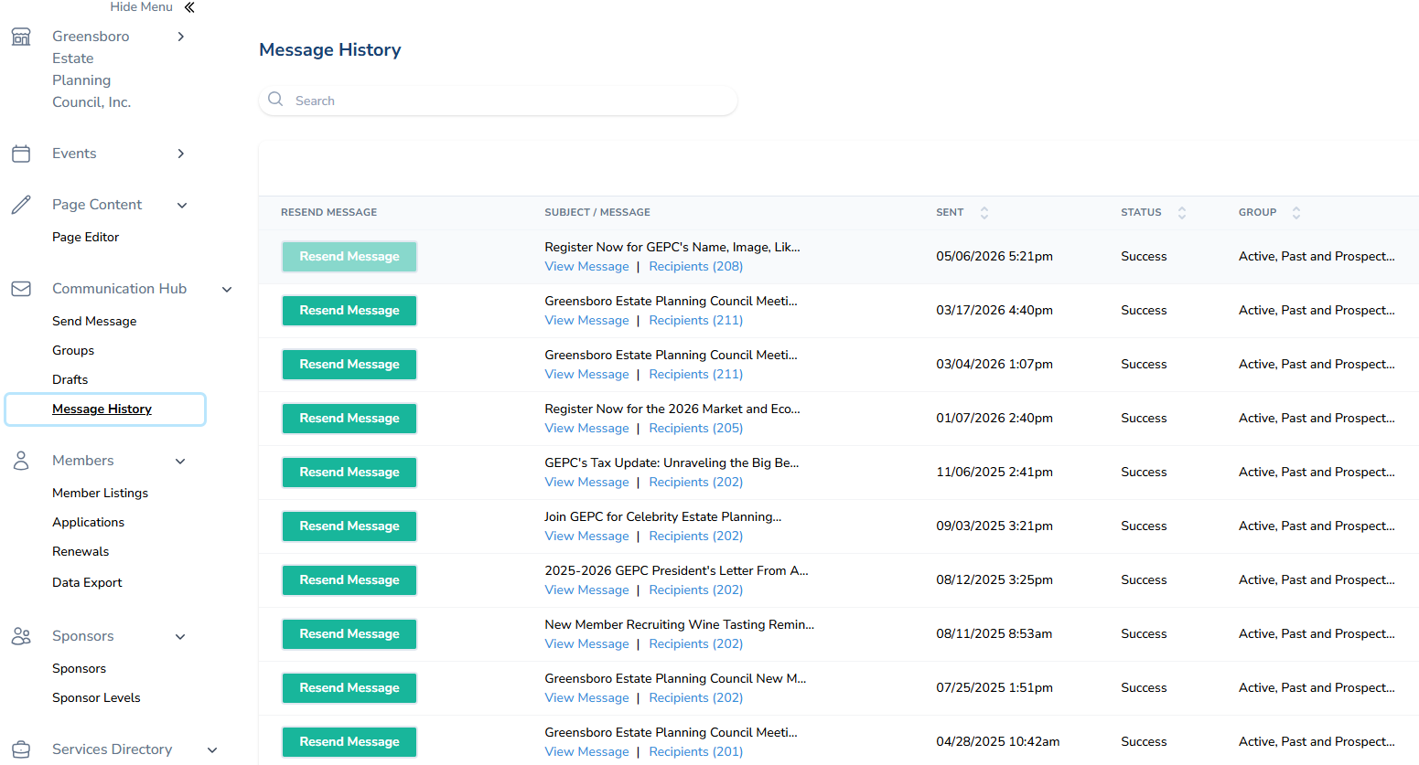

- Highlight the content. Right click. Select copy.
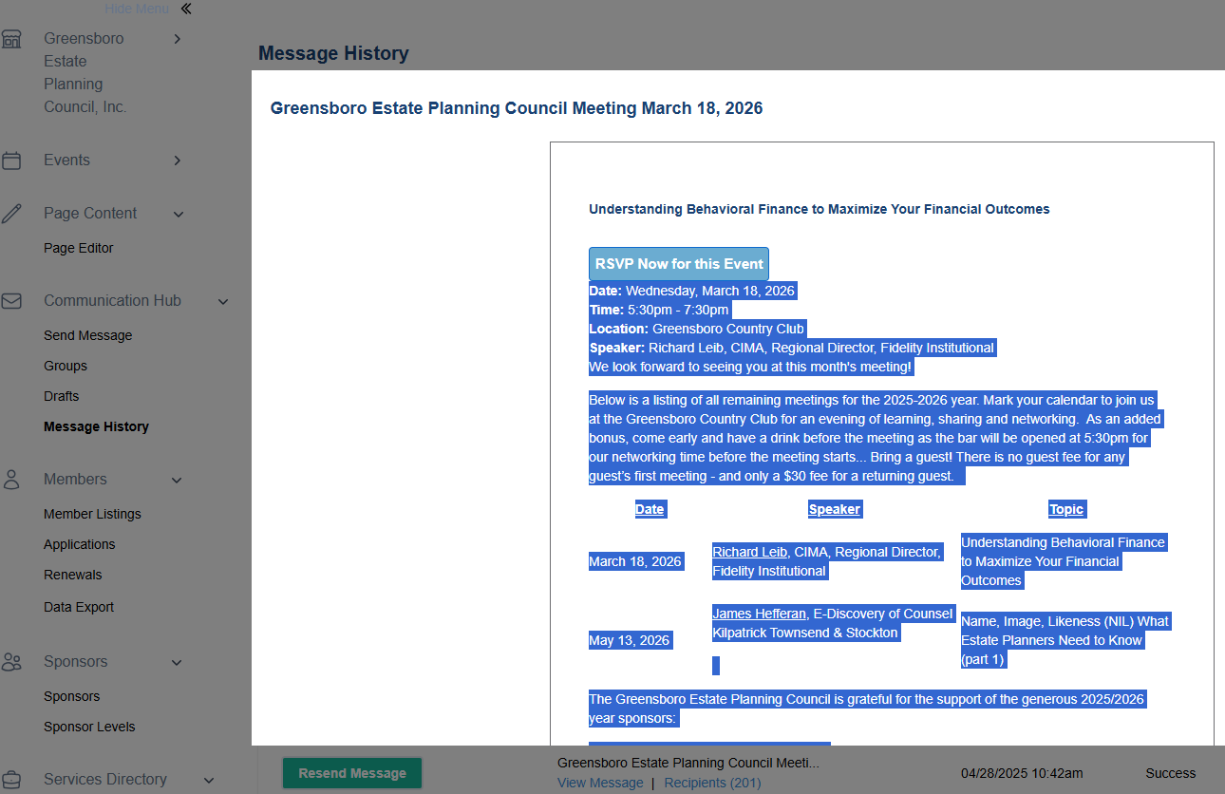

- Select Send Message from the left side. Paste the old message you just copied from the prior year example into the Message box at the bottom of the page below and update for the new year, program, etc. Input the Subject line to read something like Greensboro Estate Planning Meeting {Meeting Date} or Register Now for GEPC’s {Program Name} or whatever you feel will get the attention of the recipient. Once created, select Save Draft. (Pro Tip: Create all at the time you send the first one. Then, just return to send when it is time to send for the next meeting. ) Select Preview Message at the bottom of the page. Select Send Message at the bottom of the page.
